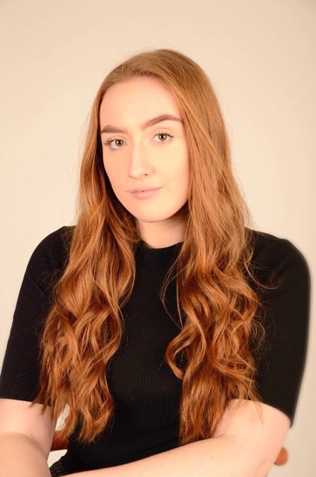
Jiordan haddley
jiordanhaddley@gmail.com 07932515674

- Long Ginger Hair
- Height: 5 Foot 8 Inches Dress Size: 14
- Liverpool Accent/Dialect
- Age: 19
- Casting Age: 18-25

Training
Attended the Dance Depot Theatre School from the age of 3-17.
Was a member of the Cronton College Centre of Excellence In Performing Arts for two years.
Is currently in second year of study for BA Honors Musical Theatre at the University of Cumbria.

STAGE Experience
Miss Trunchball | Matilda | The Dance Depot Theatre School
Annie | Annie | The Belvedere Academy
Eponine | Les Miserables | The Dance Depot Theatre School
Landlady | Two | Cronton College
Christine Daae | The Phantom Of The Opera | Cronton College Centre Of Excellence
Elvira | Blithe Spirit | Cronton College
Miss Dorothy Brown | Thoroughly Modern Millie | Cronton College Centre Of Excellence
Cosette | Les Miserables | Cronton College Centre Of Excellence
Crystal | Little Shop Of Horrors | Cronton College Centre Of Excellence

Other performing experience
- Performed a vocal set at Aintree Racecourse Family Day.
- Member of the Belvedere Academy all female chamber choir for 5 years 2011-2016.
- Performed as lead singer of a 60’s themed night entitled ‘Beehive Bop’.
- Taught musical theatre classes in The Dance Depot Theatre School for children aged from 6 to 17 for 2 years.
- Performed paid work as a princess/party character in children’s parties for two years at Jumping Jacks Parties LTD.
- Attended the Dance Depot Theatre School for Dance, Singing and Musical Theatre Lessons from the ages of 3-17.
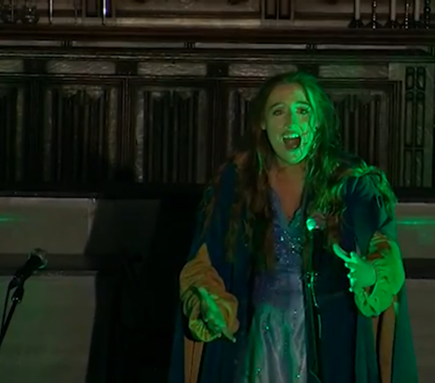
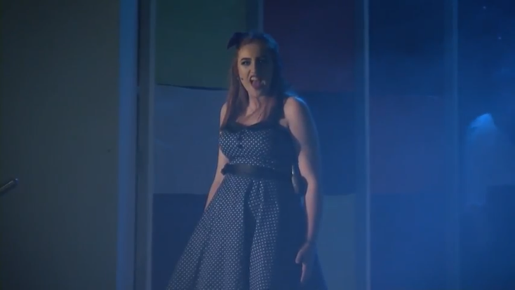
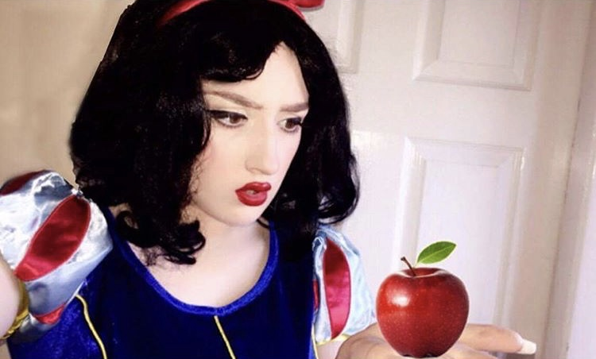
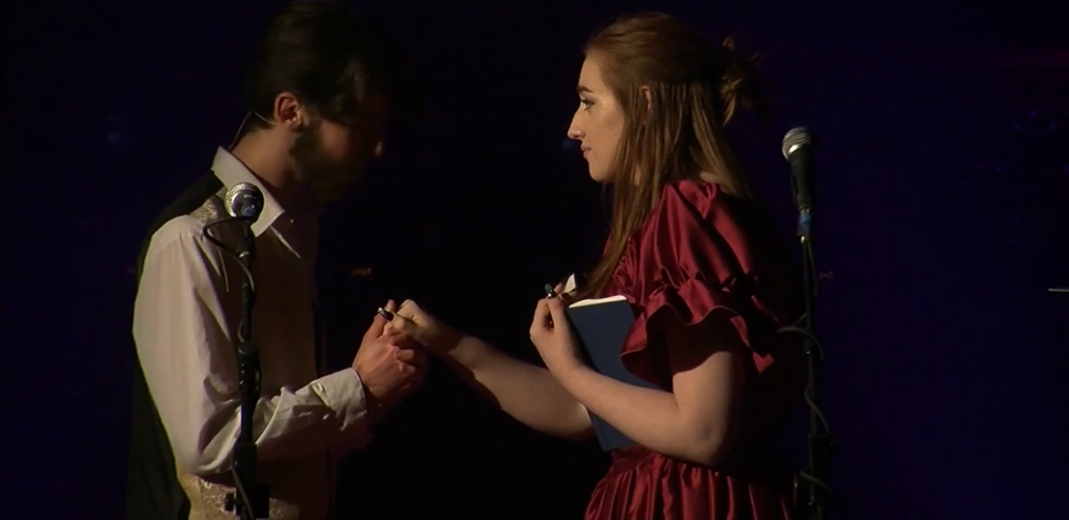
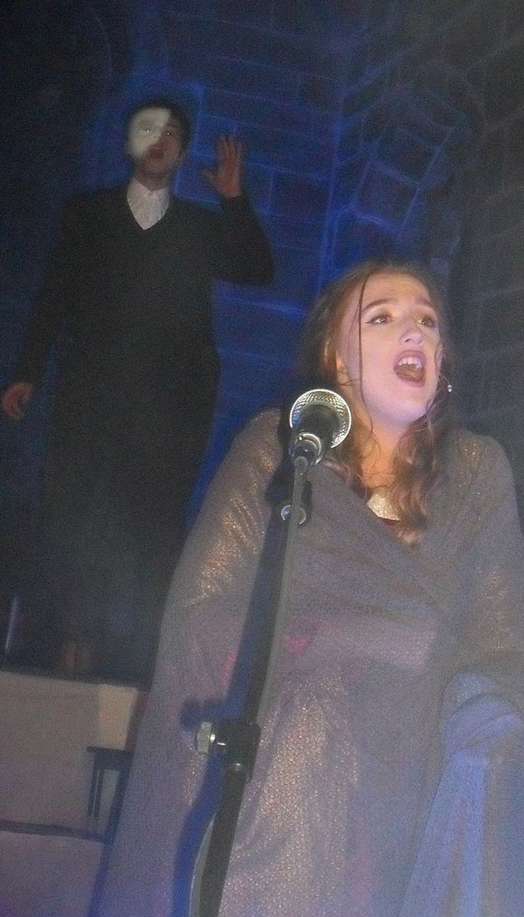
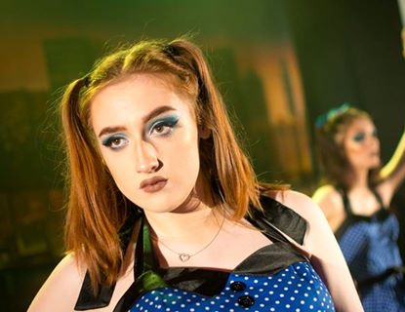
- Appeared on BBC Children In Need 2016 as Princess Ariel.

